APPLICATION OF A HYBRIDIZED LSTM-SVM IN THE DETECTION OF ARTIFACTS IN ELECTRODERMAL ACTIVITY SIGNALS FOR STRESS DETECTION

A Proposal

Presented to the Faculty of the College of Computer and Information Science

Polytechnic University of the Philippines

Sta. Mesa, Manila

In Partial Fulfillment of the Requirements for the Degree

Bachelor of Science in Computer Science

\

Benolirao, Johana

Calubayan, Christaline

Cueva, Larry Miguel

Quiray, Deseree

2024

CHAPTER 1

THE PROBLEM AND ITS SETTING

Introduction

Stress is defined as a condition that involves worry or mental strain generated by a challenging circumstance (World Health Organization, 2022). Stress can get in different aspects or events. In the country of Jordan during the COVID-19 pandemic the healthcare workers revealed that they are experiencing high level of stress and found out that 22.5% of participants had severe stress, 16.2% had extremely severe stress and 21.1% had a moderate stress in total of 60% of their healthcare workers experienced this level of stress (Alnazly et al., 2021).This high levels of stress experienced by healthcare workers during the pandemic can have negative impacts on their psychological well-being, job performance, and ability to provide quality patient care . With its negative connotations, numerous studies focused on detecting stress signals that may help in mitigating and managing stress to prevent and handle its effects better.
Furthermore, utilization of wearable sensors to detect psychological and physiological responses has been a trend over the course of years. In the investigation of Dzedzickis et. al., (2020), the researchers conducted a review of sensors and models utilized for human emotion identification. In a publication by Semmlow (2004), many physiological processes produce energy that can be detected directly by a device generally known as a transducer which converts energy from one form to another. The energy that is converted by the input transducer may be generated by the physiological processes of the body itself. The measurement of electrical activity in the heart, muscle, or brain, provides other examples of direct measurement of physiological energy. For these measurements, the energy is already electrical and only needs to be converted from ionic to an electric current using an electrode. These includes physiological processes that produces electrical energy, namely: electrocardiogram (ECG), electroencephalogram (EEG), electromyogram (EMG),
Among the techniques used in measuring physiological resp onses is Galvanic Skin Response (GSR), also known as Electrodermal Activity (EDA) or more specifically, Skin Conductance Response (SCR) measured in microsiemens (μS). It is a method of detecting the electrical attributes of human skin. Components of EDA
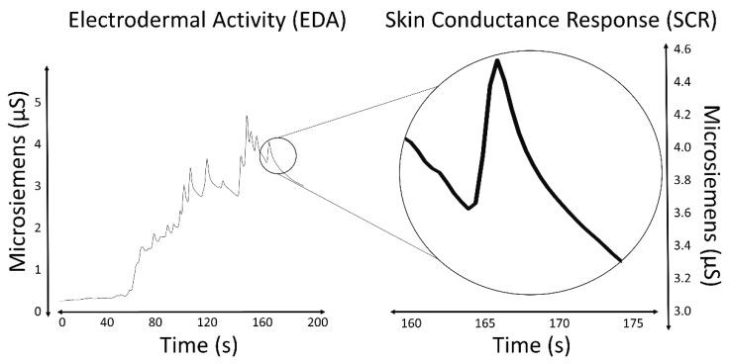
Figure 1. Skin conductance response relevant to time

Emotional fluctuations cause sweating, which is most evident on the palms, fingers, and soles. This process alters the quantity of salt in the skin and changes its electrical resistance. This sensor provides less information about the emotional state compared to EEG and ECG, but it has a few advantages: it requires fewer measuring electrodes, which allows for easier use of wearable devices and definition of emotional states in ambulatory settings; it provides fewer raw data, which allows for faster analysis of obtained data; and it requires less computational power, and compared to other measurements, equipment needed for the measurement is much simple and cheaper.
On the other hand, Jose (2022) has stated that within the domain of statistical computing, time series analysis is a statistical technique that deals with trend analysis and time series data. Time series analysis made its way into medicine when the ﬁrst practical electrocardio-grams (ECGs), which can diagnose cardiac conditions by recording the electrical signals passing through the heart, were invented in 1901. Time series analysis is a speciﬁc way of analyzing a sequence of data points collected over an interval of time. In time series analysis, analysts record data points at consistent intervals over a set period of time rather than just recording the data points intermittently or randomly.
Having established that signals measured from ECGs, EEGs, EMGs, and GSRs/EDAs all have similar characteristics in that they are sequences of data points collected over an interval of time, GSR or EDA data therefore can be categorized as time series specific data. Electrodermal Activity (EDA) is a low-cost and non-intrusive way of monitoring the emotional state of a subject, and a viable gateway\\ to study the Sympathetic Nervous System (SNS), which is responsible for the so-called ﬁght-or-ﬂight responses happening at the unconsciousness level (Boucsein, 2012). EDA is also a frequently used modality in psychophysiology, because of its ability to obtain a distinct Electrodermal Response (EDR) in response to a stimulus. The possible uses of EDA are well documented; the most important examples include research on epilepsy, autism, stress and anxiety (Banganho, et. al., 2022).
Nonetheless, similar to other physiological signals, EDA signals face challenges. With the recent trend of wearable technologies for psychophysiological monitoring in ambulatory settings, the data quality from these sensors can be compromised by "noise" or artifacts in long-term recordings. Artifacts, which are unwanted changes in recorded biosignals not originating from the intended source (Boucsein, 2012), can result from unstable electrode contact, environmental factors like temperature and humidity, or movement (Hossain, 2022). According to Boucsein (2012), detecting these artifacts typically requires visual inspection of the data. While signal processing techniques like low-pass filtering can be used to reduce the need for visual inspection, they risk altering the physiological response, potentially transforming the entire EDA trace and making artifacts appear as genuine responses. Recent studies have focused on developing models to automatically identify and remove artifacts (Gashi et al., 2020).
In the study conducted by Llanes-Jurado et. al. (2023) on automatic recognition and elimination of artifacts in electrodermal activity (EDA) signals using their EDABE dataset, they collected data from 43 participants in a stress-inducing VR study. The researchers developed and trained four models, two of which replicated traditional machine learning methods by Taylor et al. (2015) and Hossain et al. (2022).
Replicating the Taylor et al. (2015) method, they extracted 62 hand-crafted features, selected 40 via backward selection with a Support Vector Classifier, and used three classifiers: Logistic Regression, Support Vector Classifier, and Random Forest. They performed hyperparameter tuning and selected the model with the highest accuracy.
Additionally, they also had reimplemented the same methodology used in the recent paper by Hossain et al. (2022), where instead of 5s segments as it was in the latter paper, they used 0.5s segments of EDA signals. They engineered typical statistical features as with the paper by Taylor et al. (2015). The researchers included the optimized coefficients of an autoregressive model as features, excluding the bias or intercept coefficient. Finally, they used two time frequency transformation methods to extract time frequency features in order to capture non-stationary characteristics from the signals. A total of 50 features were engineered and extracted from the raw EDA signal data, then reduced to 40 using a Random Forest classifier as a feature selection method. The features before being fed as input for Support Vector Machine, Gradient Boosted Tree, Random Forest, and Logistic Regression classifiers were standard scaled and normalized using min-max. In order to select the best model for each classifier, the use of hyperparameter tuning has been repeated for each classifier together with the use of 5-fold cross validation to select the best model out of each classifier. The model that had the highest accuracy out of each classifier category was defined as the best model.
In addition to these, they proposed new models, which includes LSTM with a 1D-CNN and a 2D-CNN for analyzing signal spectrograms. The LSTM-1D CNN model recognized 72% of artifacts with 88% accuracy on the test set. Future work includes adding expert manual correction, developing movement protocols, and fine-tuning model architectures. This study reaffirmed that SVM, Gradient Boosted Tree, and Random Forest classifiers achieved the best accuracy on the validation set, consistent with previous findings.
In another study of Lee et al. (2020), artifact detection is a crucial aspect addressed in the research. The denoising method proposed in the study focuses on alleviating intrinsic respiration noise and extrinsic noise in Electrodermal Activity (EDA) signals collected by a wearable biosensor. The method involves detecting and attenuating irregular respiration-induced noise in EDA signals. Specifically, irregular respiration is identified and removed as respiration noise using a machine learning model that detects irregular respiration patterns from Photoplethysmography (PPG) signals collected simultaneously. This artifact detection process is essential for improving the accuracy of stress measurement by reducing noise interference in EDA signals, thus enhancing the reliability of stress metrics extracted from the data.
Despite these findings, traditional machine learning methods have limitations in healthcare signal processing. Sun et al. (2018) found that hand-designed EEG feature extraction methods resulted in poor analytical performance. They addressed this by using recurrent autoencoders for feature extraction. Hussein et al. (2018) further supported this by employing LSTM networks to capture high-level patterns in EEG signals. In their approach, a fully connected layer was used to extract robust, epileptic-relevant features, while a softmax layer provided predicted labels. This method maintained high detection performance, particularly in identifying artifacts like eye movements, muscle movements, and background noise.
In this study, the researchers propose the use of a hybridized LSTM-SVM classifier in the detection of artifacts in electrodermal activity signal data, in contrast to the previously developed approaches to applying machine learning methods such as the investigations previously done by Hossain et. al. (2022) and Taylor et. al. (2015).

Statement of the Problem
- What would be the performance of the hybridized LSTM-GB model compared to the existing automatic detection and removal models in terms of its:
- Accuracy
- Precision
- Recall
- F1-Score
- What is the optimal learning rate for training the hybridized LSTM-GB model to achieve higher performance metrics than the other state of the art ML techniques such as SVM, KNN, Decision Tree?

Theoretical Framework
The purpose of this study is to improve the detection of anomalies in electrodermal activity (EDA) signals by utilizing advanced machine learning methodologies, specifically through a hybridized Long Short Term Memory (LSTM) infused with Support Vector Machine (SVM). This strategy will be contrasted with conventional machine learning approaches like Support Vector Machines, Linear Regression, Random Forests, and Naive Bayes, which have been previously utilized in stress recognition research.
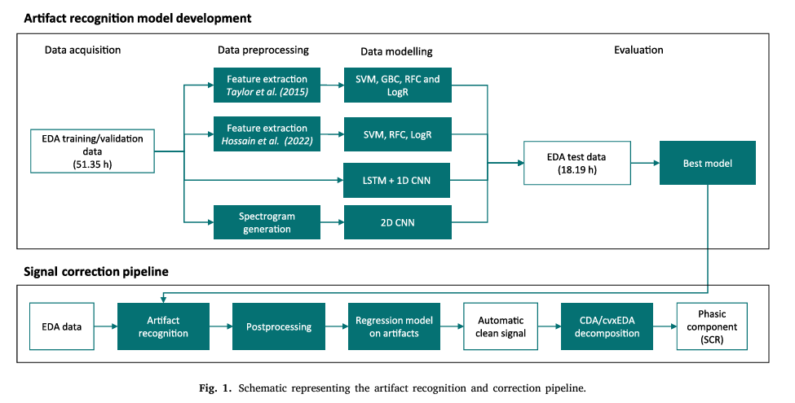
- Machine Learning and Deep Learning Theories
1.1. LSTM & SVM: Long Short Term Memory (LSTM) networks and Support Vector Machines (SVM) are both prominent techniques in the realm of machine learning, each offering distinct advantages in handling sequential and non-linear data, respectively. The hybridization of LSTM with SVM offers a promising approach to utilize the strengths of both models for improved anomaly detection in electrodermal activity (EDA) signals, particularly in the context of stress detection.

- Signal Processing Theory
2.1. Electrodermal Activity (EDA): The measurement of Electrodermal Activity (EDA) involves assessing the skin's electrical conductance, which fluctuates in response to sweat gland activity and is modulated by the sympathetic nervous system. This method is frequently utilized in the identification of stress and in psychophysiological investigations. For a precise analysis of EDA signals, it is imperative to conduct efficient artifact removal procedures to ensure that the collected data accurately represents genuine physiological responses, rather than being distorted by noise or artifacts stemming from motion or environmental factors.
2.2. Artifact Detection in EDA Signals: The presence of artifacts within EDA signals can have a notable impact on the precision of stress detection models. Traditional techniques for identifying artifacts typically entail manual scrutiny or the application of heuristic algorithms, which can be labor-intensive and may yield suboptimal results. The proposed utilization of Seq2Seq models incorporating Bidirectional LSTM and GRU is aimed at streamlining and enhancing the accuracy of artifact detection through the exploitation of deep learning's capacity to capture intricate, non-linear patterns within the data.

- Stress Detection Framework
3.1. Machine Learning in Stress Detection: Conventional machine learning techniques such as Support Vector Machine, Linear Regression, Random Forests, and Naive Bayes have been extensively utilized for stress identification utilizing physiological signals. These approaches usually necessitate thorough feature manipulation and may not entirely capture the temporal dynamics of EDA signals. In contrast, Sequence-to-Sequence models can acquire knowledge directly from unprocessed data, potentially resulting in enhanced performance in identifying and rectifying anomalies.
3.2. Comparative Analysis: This analysis will evaluate the efficiency of Sequence-to-Sequence models in comparison to conventional machine learning methods. Essential criteria for evaluation will encompass precision, recall, and computational efficiency. The claim argues that Sequence-to-Sequence models, particularly those employing Bidirectional Long Short-Term Memory (LSTM) and Gated Recurrent Unit (GRU), will excel over conventional techniques in anomaly detection within EDA signals by effectively utilizing contextual information from both preceding and subsequent data points.

Through analyzing these models with conventional artificial intelligence methodologies, this investigation seeks to enrich the domain of tension identification by enhancing the precision and dependability of EDA signal analysis.
This framework will guide the research design, data collection, analysis, and interpretation, ensuring a comprehensive evaluation of the proposed methods.

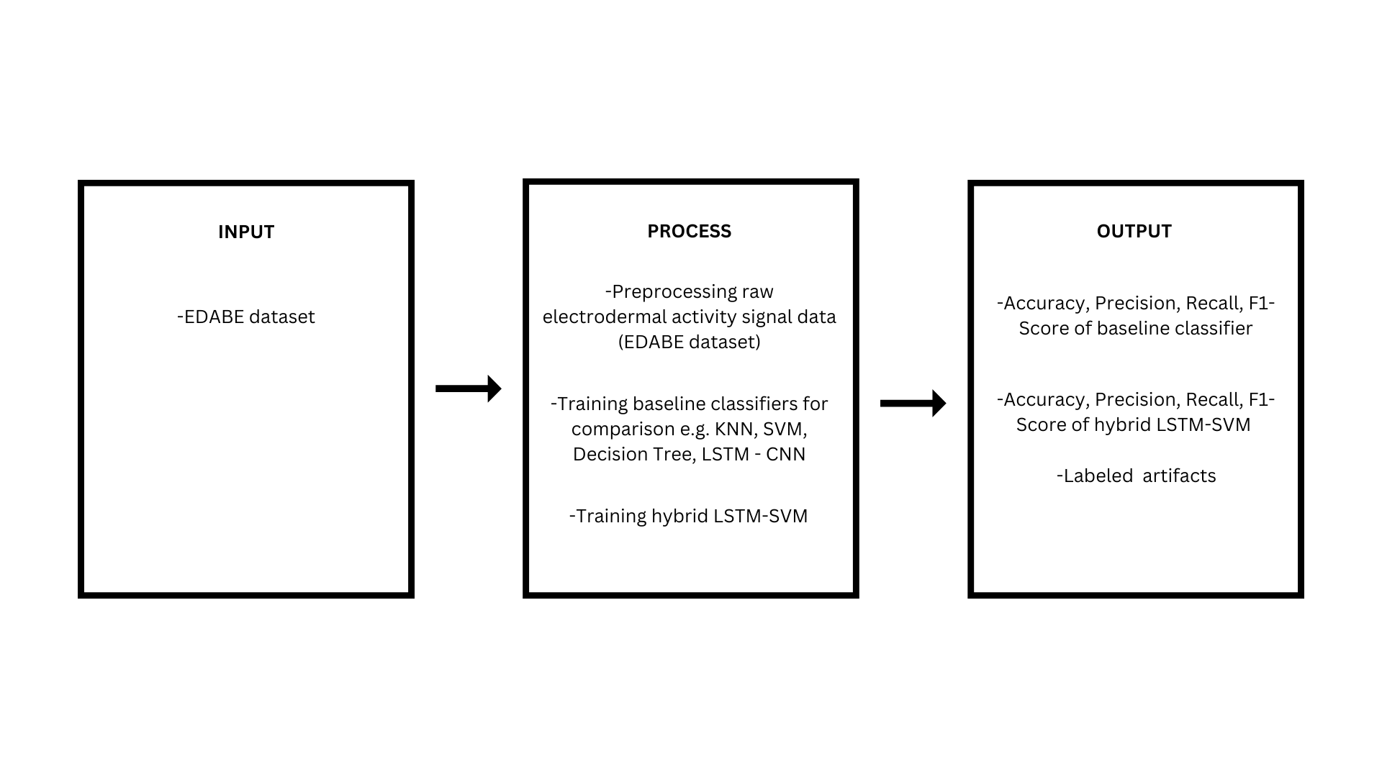
Conceptual Framework
Figure 3. Conceptual Framework
In this framework, we present the variables of the study and their relationships. We have proposed a hybridized LSTM-SVM, the traditional models to be compared with, and the raw EDA signals to be used as the independent variables. On the other hand, detection accuracy, precision, recall, and the final data falls under the dependent variable. We can see that there is a direct relationship between the variables that are included in the study. The proposed hybridized LSTM-SVM model used in the raw EDA signal data from a dataset and Traditional ML Models that will be compared with it directly affects the performance accuracy, precision, and result of the data.

Hypotheses of the Study
There is no significant difference between the performance of the hybridized LSTM-SVM model compared to the existing automatic detection and removal models in terms of accuracy, precision, recall, and F1-score.

Scope and Delimitations
This study focuses on the application of hybridized Long Short Term Memory (LSTM) with Support Vector Machine (SVM) in the detection of artifacts in Electrodermal Activity signals for stress detection. The study will utilize the use of pre-existing datasets, specifically the EDABE datasets which contain electrodermal activity (EDA) recordings of hand and body motion artifacts. This study is limited only in detection of artifacts and not the removal of artifacts. The process of this study includes the collection of preprocessing electrodermal activity (EDA) data, identifying artifacts, and training the hybridized LTSM-SVM using the processed data to differentiate between authentic physiological signals and artifacts.

Significance of the Study
This study holds significance in the improvement in Electrodermal Activity (EDA) for stress detection.This study will be beneficial for the following:

Caretakers. This study will allow caretakers to potentially be able to identify and distinguish what is noise from what is a real stress response.
Healthcare Professionals. This study may help healthcare professionals under the pressure of time in ambulatory situations to easily interpret and distinguish what is noise/artifacts from the stress response of a patient.
Healthcare Technology Companies. This study may grasp this advancement to develop more precise, non-surgical stress detection devices, leading to better stress management solutions and ultimately to improve patient outcomes and quality of life.
Future Researchers. This study will help future researchers to build on this hybrid approach to enhance the accuracy of data that leads to more reliable result and to overall performance of EDA-based stress detection, potentially leading to more advanced and practical applications in health monitoring, psychological assessment, and stress monitoring devices

Definition of Terms
Ambulatory Settings - it refers to medical services performed on an outpatient basis, without admission to hospital or other facility. Ambulatory setting is also defined as any environment where patients receive healthcare services without being admitted to hospital. This includes clinics, doctor’s offices and home-base care environments where EDA signals might be collected.
Artifact/Artefact - refers to unwanted disturbances or noise in EDA data that can compromise the accuracy of the measurements. It can arise due to various factors including motion, quantization errors, sudden changes in EDA associated with movement, or other sources of interference. As any anomalies in the EDA signal data that do not originate from the physiological responses but from external or technical sources. These need to be detected and filtered out to ensure the accuracy of the stress detection.
Electrodermal Activity - pertains to the skin’s electrical properties that shift in response to sweat secretion. These changes are frequently associated with mental and physical arousal. EDA is measured as the variation in the electrical conductance of the skin over time, reflecting the physiological arousal related to stress. The signals are collected using sensors and analyzed to detect stress levels.
Gated Recurrent Unit - is a type of recurrent neural network (RNN) that was introduced by Cho et al. in 2014 as a simpler alternative to Long Short-Term Memory (LSTM) networks. GRU is used as component of the hybridized model for processing time series EDA data, offering a simpler yet efficient way to capture dependencies in the sequential data.
Long-Short Term Memory - is a type of deep neural network that is designed to capture historical information of time series data and is suitable for predicting long-term nonlinear series. LSTM are employed to analyze and predict patterns in EDA signals by retaining information over longer periods, which helps in identifying stress related changes in the data.
Microsiemens (μS) - It is the unit of measurement for skin conductance, which is a key component for EDA. This study’s goal is to use a machine learning approach to filter out noise and improve the reliability of stress detection from EDA signals.
Non-Stationary - refers to a process of time series of statistical properties, such as mean, variance, and autocorrelation that change over time.It can also arise due to trends, cycles, abrupt changes, or other time-varying behavior in the data. This involves identifying and addressing the time-varying nature of these EDA signals when detecting artifacts.
Psychophysiological Signals - refers to physiological responses of the human body that are influenced by psychological factors. These signals include EDA, heart rate, respiration rate and blood pressure but it is not limited. It specifically focuses on EDA signals, which are measurements of the skin’s electrical conductance caused by sweat gland activity. EDA is closely related to the sympathetic nervous system’s activity and is often used as an indicator of emotional arousal or stress detection.
Recurrent Neural Network - is a deep learning model that is trained to process and convert a sequential data input into a specific sequential data output. RNNs including their variants like LSTM and GRU, are utilized to handle the sequential nature of the EDA data, enabling the detection of stress over time.
Sequential Models - a class of machine learning models designed for tasks that involve sequential data, where the order of elements in the input is important. Sequential data includes textual data, time series data, audio signals, video streams or any other ordered data. Sequential models the one that processes the EDA signal data to detect artifacts and subsequently stress patterns.
Stationary - It is the contrast of nonstationary processes, where the statistical properties such as mean, variance and autocorrelation, do not change over time. By identifying the segments of the signal that deviated, this can pinpoint the artifacts. Also, by analyzing its properties of the signals this can differentiate between normal variations and stress-induced changes.

References
Banganho, António & Santos, Marcelino & Plácido da Silva, Hugo. (2022).
Electrodermal Activity: Fundamental Principles, Measurement and Application. IEEE Potentials. 41. 35-43. 10.1109/MPOT.2020.2983381.

Dzedzickis, A., Kaklauskas, A., & Bucinskas, V. (2020, January 21). Human Emotion
Recognition: Review of Sensors and Methods. Sensors. https://doi.org/10.3390/s20030592

Gashi, S., Di Lascio, E., Stancu, B., Swain, V. D., Mishra, V., Gjoreski, M., & Santini,
S. (2020). Detection of Artifacts in Ambulatory Electrodermal Activity Data. Proceedings of the ACM on Interactive, Mobile, Wearable and Ubiquitous Technologies, 4(2), 1–31. doi:10.1145/3397316

Hossain, M. B., Posada-Quintero, H. F., Kong, Y., McNaboe, R., & Chon, K. H. (2022, April 1). Automatic motion artifact detection in electrodermal activity data using machine learning. Biomedical Signal Processing and Control. https://doi.org/10.1016/j.bspc.2022.103483

Lee, G., Choi, B., Jebelli, H., Ahn, C. R., & Lee, S. (2020). Noise reference Signal–Based denoising method for EDA collected by multimodal biosensor wearable in the field. Journal of Computing in Civil Engineering, 34(6). https://doi.org/10.1061/(asce)cp.1943-5487.0000927

Llanes-Jurado, J., Carrasco-Ribelles, L. A., Alcañiz, M., Soria-Olivas, E., & Marín-Morales, J. (2023, November 1). Automatic artifact recognition and correction for electrodermal activity based on LSTM-CNN models. Expert Systems With Applications. https://doi.org/10.1016/j.eswa.2023.120581

Stress. (2022, June 17). https://www.who.int/news-room/questions-and-answers/item/stress#:~:text=Stress%20can%20be%20defined%20as,experiences%20stress%20to%20some%20degree

Boucsein, W. (2012). Electrodermal activity. In Springer eBooks. https://doi.org/10.1007/978-1-4614-1126-0

Sun, L., Jin, B., Yang, H., Tong, J., Liu, C., & Xiong, H. (2018). Unsupervised EEG feature extraction based on echo state network. Information Sciences, 475, 1–17. https://doi.org/10.1016/j.ins.2018.09.057

Semmlow, J. L. (2004). Biosignal and medical image processing. CRC Press.

Jose, J. (2022). INTRODUCTION TO TIME SERIES ANALYSIS AND ITS APPLICATIONS.ResearchGate.https://www.researchgate.net/publication/362389180_INTRODUCTION_TO_TIME_SERIES_ANALYSIS_AND_ITS_APPLICATIONS

Hussein, R., Palangi, H., Ward, R. K., & Wang, Z. J. (2019). Optimized deep neural network architecture for robust detection of epileptic seizures using EEG signals. Clinical Neurophysiology, 130(1), 25–37. https://doi.org/10.1016/j.clinph.2018.10.010

Nagabushanam, P., George, S. T., & Radha, S. (2019). EEG signal classification using LSTM and improved neural network algorithms. Soft Computing, 24(13), 9981–10003. https://doi.org/10.1007/s00500-019-04515-0

Mohsen, S., Ghoneim, S. S. M., Alzaidi, M. S., Alzahrani, A., & Hassan, A. M. A. (2023). Classification of electroencephalogram signals using LSTM and SVM based on Fast Walsh-Hadamard Transform. Computers, Materials & Continua/Computers, Materials & Continua (Print), 75(3), 5271–5286. https://doi.org/10.32604/cmc.2023.038758

Khorram, A., Khalooei, M., & Rezghi, M. (2020). End-to-end CNN + LSTM deep learning approach for bearing fault diagnosis. Applied Intelligence, 51(2), 736–751. https://doi.org/10.1007/s10489-020-01859-1

Orlanda-Ventayen, C., & Ventayen, R. J. (2022). Stress and depression in the workplace of educators in the Philippines. International Journal of Occupational Safety and Health, 12(4), 325–335. https://doi.org/10.3126/ijosh.v12i4.43226
Kortum, E., Leka, S., & Cox, T. (2010). Psychosocial risks and work-related stress in developing countries: health impact, priorities, barriers and solutions. International Journal of Occupational Medicine and Environmental Health, 23(3). https://doi.org/10.2478/v10001-010-0024-5

C. Szegedy, V. Vanhoucke, S. Ioffe, J. Shlens, Z. Wojna
Rethinking the inception architecture for computer vision
Proceedings of the IEEE Computer Society Conference on Computer Vision and Pattern Recognition, 2016-Decem, 2818–2826 (2016), 10.1109/CVPR.2016.308

B. Wang, R. Ma, J. Kuang, Y. Zhang
How decisions are made in brains: Unpack “Black Box” of CNN with Ms. Pac-Man Video Game
IEEE access : practical innovations, open solutions, 8 (2020), pp. 142446-142458, 10.1109/ACCESS.2020.3013645

Y. Park, H.S. Yang
Convolutional neural network based on an extreme learning machine for image classification
Neurocomputing, 339 (2019), pp. 66-76, 10.1016/j.neucom.2018.12.080

S. Li, X. Zhao, L. Stankovic, D. Mandic
Demystifying CNNs for Images by Matched Filters (2022), pp. 1-10

Lange, T.De, Hicks, S.A., Riegler, M., Pogorelov, K., Anonsen, K.V., Johansen, D. et al.. (2018). Dissecting Deep Neural Networks for Better Medical Image Classification and Classification Understanding. 10.1109/CBMS.2018.00070

Ferdinand, K., & Mercier, D. (n.d.). TSXplain : Demystification of DNN Decisions for Time-Series using Natural Language and Statistical Features.

M. Brahimi, M. Arsenovic, S. Laraba, S. Sladojevic, K. Boukhalfa, A. Moussaoui
Deep learning for plant diseases : Detection and saliency map visualisation
Springer International Publishing (2018), 10.1007/978-3-319-90403-0

Dependent, M., Breast, H., & Explanation, V. (2021). Conventional Machine Learning versus Deep Learning for Magnification Dependent Histopathological Breast Cancer Image Classification : A Comparative Study with Visual Explanation.

Yanase, J., & Triantaphyllou, E. (2019). The seven key challenges for the future of computer-aided diagnosis in medicine. In International journal of medical informatics (Vol. 129, pp. 413–422). Elsevier Ireland Ltd. 10.1016/j.ijmedinf.2019.06.017

Lin, X., Lei, Y., Chen, J., Xing, Z., Yang, T., Wang, Q. et al. (n.d.). A Case-Finding Clinical Decision Support System to Identify Subjects with Chronic Obstructive Pulmonary Disease Based on Public Health Data.

F. Giuste, W. Shi, Y. Zhu, T. Naren, M. Isgut, Y. Sha, et al.
Explainable artificial intelligence methods in combating pandemics: A systematic review
IEEE Reviews in Biomedical Engineering (2022), 10.1109/RBME.2022.3185953
Alnazly, E., Khraisat, O. M., Al-Bashaireh, A. M., & Bryant, C. L. (2021). Anxiety, depression, stress, fear and social support during COVID-19 pandemic among Jordanian healthcare workers. PloS One, 16(3), e0247679. https://doi.org/10.1371/journal.pone.0247679

